Roll No.:2503a52531
Name:B.Poojitha
Batch:18
Question 2: One-Shot Prompting (Factorial Calculation)
Write a one-shot prompt by providing one input-output example and
ask the AI to generate a Python function to compute the factorial of a
given number.
Example:
Input: 5 → Output: 120
Task:
• Compare the generated code with a zero-shot solution.
• Examine improvements in clarity and correctness.

Prompt:
Write a Python function to calculate the factorial of a given number.
Example:
Input: 5
Output: 120
Now generate the Python code following the same pattern.
Code:
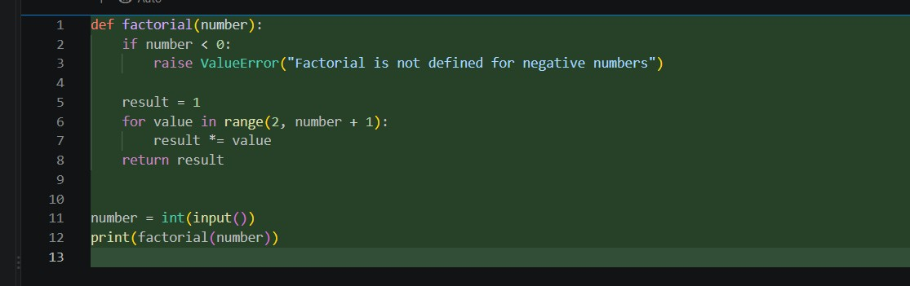

Output:
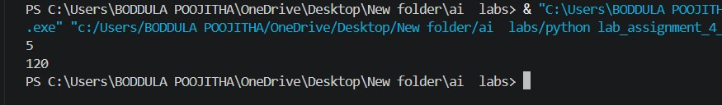

Observation:
1. The one-shot prompt generated a Python function to calculate the factorial of a given number.
2. The example 5 → 120 helped the AI understand the expected input-output format.
3. The generated code was clear and easy to understand.
4. It correctly calculated factorial values for normal positive inputs.
5. Compared with the zero-shot solution, the one-shot code was more specific and structured.
6. The code can handle 0! = 1 correctly if proper logic is used.

